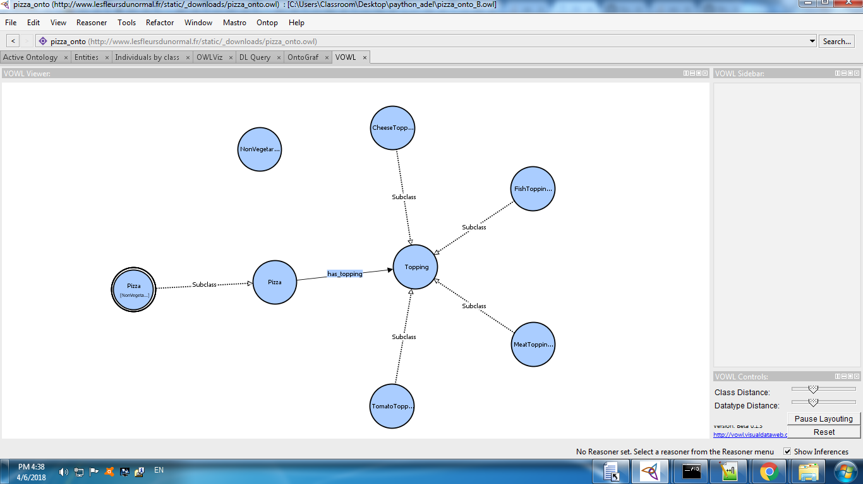

Figure : VOWL+printScreen

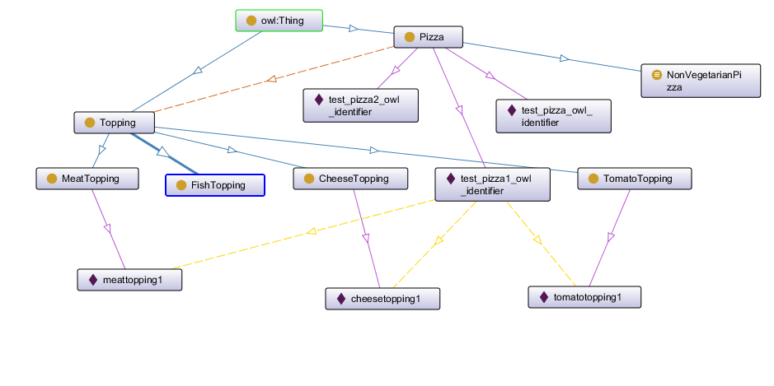

Figure : OntoGraph

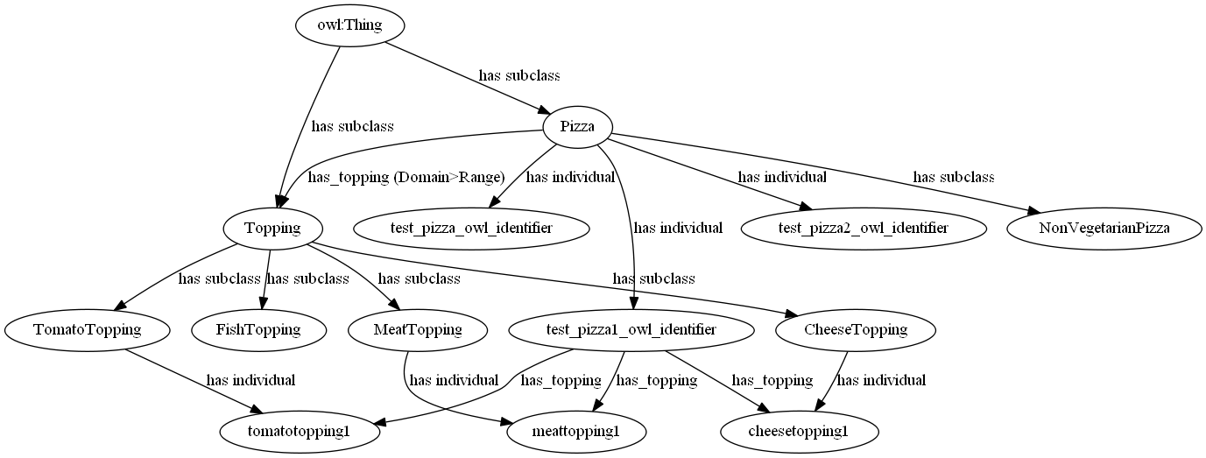

Figure : OntoGraph export to DOT/Graphviz

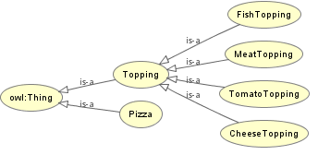

Figure : OWLviz

import owlready2

from owlready2 import *

# owlready2.JAVA_EXE = "\\path\\to\\java.exe"

owlready2.JAVA_EXE = "C:\\Program Files\\Java\jre-10\\bin\\java.exe"

onto=onto_path.append("C:/Users/Classroom/Desktop/paython_adel")

onto = get_ontology("http://www.lesfleursdunormal.fr/static/_downloads/pizza_onto.owl")

## onto = get_ontology("file://C:/Users/Classroom/Desktop/paython_adel/pizza_onto1.owl")

onto.load()

onto.save()

class NonVegetarianPizza(onto.Pizza):

equivalent_to = [

onto.Pizza

& ( onto.has_topping.some(onto.MeatTopping)

| onto.has_topping.some(onto.FishTopping)

) ]

def eat(self): print("Beurk! I'm vegetarian!")

onto.Pizza

test_pizza1 = onto.Pizza("test_pizza1_owl_identifier")

test_pizza2 = onto.Pizza("test_pizza2_owl_identifier")

test_pizza1.has_topping = [ onto.CheeseTopping(),

onto.TomatoTopping(),

onto.MeatTopping () ]

onto.save()

test_pizza.__class__

sync_reasoner()

test_pizza.__class__

test_pizza.eat()

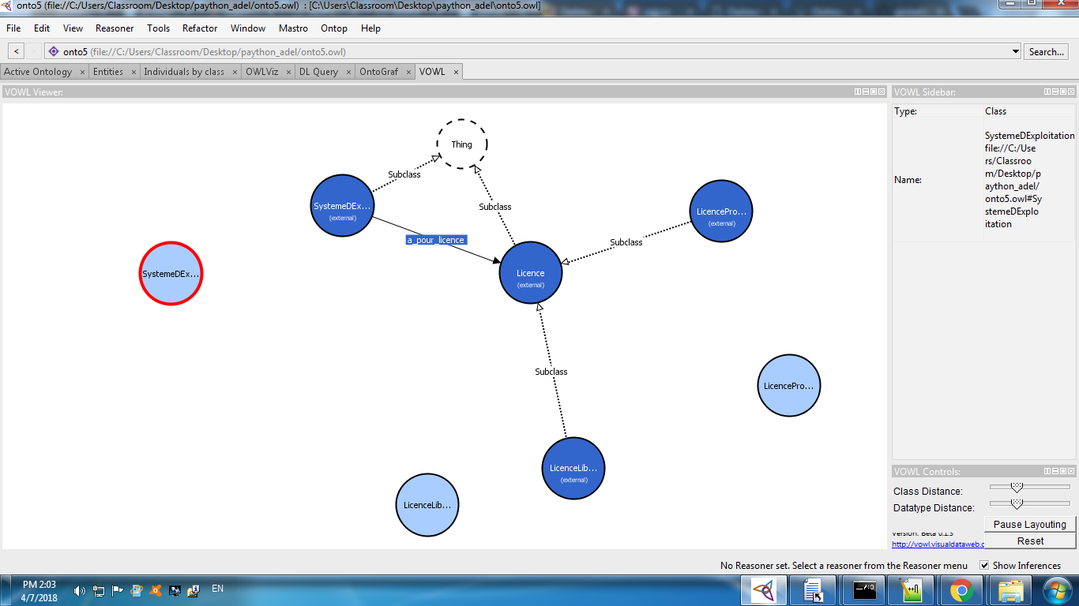

import owlready2

from owlready2 import *

onto5=onto_path.append("C:/Users/Classroom/Desktop/paython_adel/")

onto5 = get_ontology("file://C:/Users/Classroom/Desktop/paython_adel/onto5.owl")

# onto = get_ontology("http://test.org/onto.owl")

onto5.load()

with onto5:

class Licence(Thing): pass

class LicenceLibre(Licence): pass

class LicenceProprietaire(Licence): pass

licence_proprio = LicenceProprietaire("licence_proprio")

gpl = LicenceLibre("gpl")

lgpl = LicenceLibre("lgpl")

class SystemeDExploitation(Thing): pass

class a_pour_licence(ObjectProperty):

domain = [SystemeDExploitation]

range = [Licence]

gnu_linux = SystemeDExploitation("gnu_linux")

gnu_linux.a_pour_licence = [gpl]

windows = SystemeDExploitation("windows7")

windows.a_pour_licence = [licence_proprio]

class SystemeDExploitationLibre(Thing):

equivalent_to = [ SystemeDExploitation & a_pour_licence.some(LicenceLibre) ]

onto5.save()

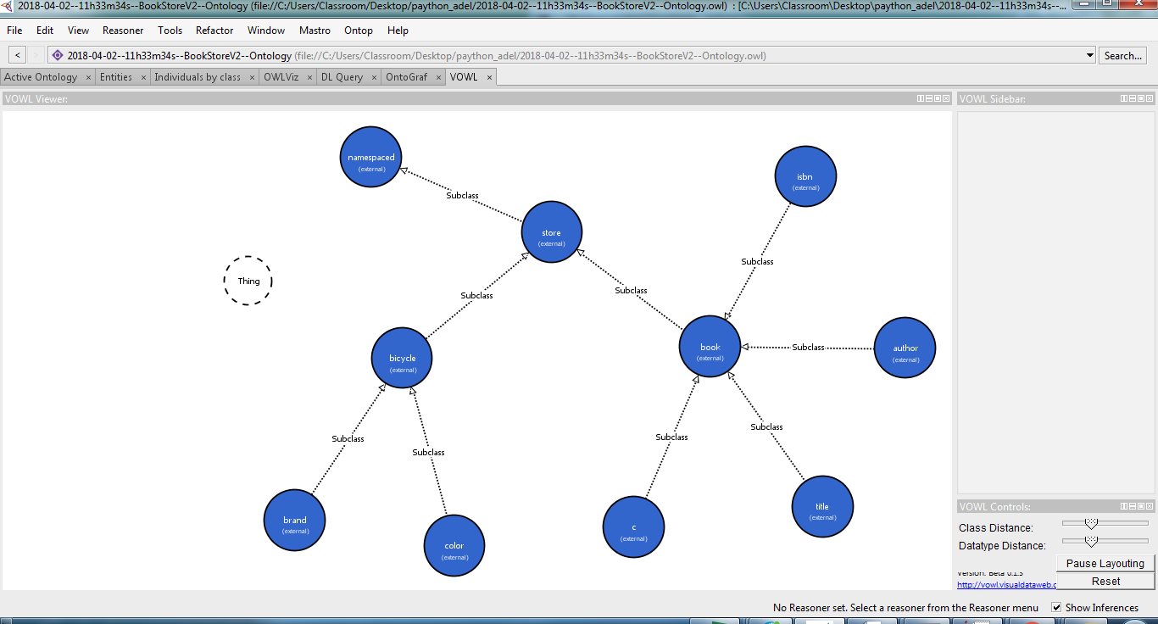

Figure : Automated generated ontology from BookStore-V2.xml

import owlready2

from owlready2 import *

T2_inputdataFile="2018-04-02--11h33m34s--BookStoreV2--T2.txt"

OWL_outputOntologyFile=T2_inputdataFile.replace("txt", "owl")

OWL_outputOntologyFile=OWL_outputOntologyFile.replace("T2", "Ontology")

print("Output Ontology to file : ", OWL_outputOntologyFile, "\n")

onto5 = onto_path.append("C:/Users/Classroom/Desktop/paython_adel")

urilocale="file://C:/Users/Classroom/Desktop/paython_adel/" + OWL_outputOntologyFile

onto5 = get_ontology(urilocale)

'''Fetch the data from source file and split the data line by line then put them in format of list of lists'''

#rawdata = open('c:/Users/mohd/OneDrive/Data Analysis Faouzi/data.txt').read()

T2_inputdataFile="2018-04-02--11h33m34s--BookStoreV2--T2.txt"

print("Input T2 from file : ", T2_inputdataFile, "\n")

rawdata = open(T2_inputdataFile).read()

rawdata=rawdata.replace('-','')

rawdata=rawdata.replace('}','')

data = rawdata.split('\n')

dataset = [word.split(';') for word in data]

CL=[]

for e in dataset:

i=1

for v in e:

print(v)

if i<3 and v not in CL :

CL.append(v)

i=i+1

else : i=i+1

print(CL)

PC={}

v0=""

for c in CL:

trouve=False

for l in dataset:

i=1

v0=""

for v in l:

if c == v :

if i==1 :

break

# continue interrupt current ietration and go to next iteration in same loop

# exit this line and iterate next line

elif i==2 :

# c=v c la classe et v0 est sa classe parent

PC[c]=v0

v0=""

trouve=True

break

# exit for for and iterate for c in CL

else : # traiter case i=3..4

pass

else :

pass

v0=v

i=i+1

# si fin fichier est c non trouvee if (trouev==False) alor add PC[c]='Thing'

if (trouve==False) :

PC[c]='Thing'

pass

else :

break

tab=" "

# CL={'Store','Book','Title','Author','ISBN','Bicycle'}

with onto5 :

for c in CL:

classString = "class " + c + "(" + PC[c] + ")" + ":" # onto.Pizza

classString = classString + tab + "pass" #"equivalent_to" + " = [" + "onto.Pizza" + " ]"

print(classString)

exec(classString)

onto5.save()